Student Name(s): Arash Mahboobhosseini and Vivian John Goshashy
Group Name (Match Canvas): Group 6
There are ten formal question and one open ended question – Make sure you note all pages.
IMPORTANT NOTE: Do NOT extract anything beyond the registry, $I, $R, or $MFT files from the FEF. DO NOT EXTRACT OR EXECUTE any scripts found inside the image!
- What is the calculated hash of the FEF?
The calculated MD5 hash of the forensic image (Laptop1Final.E01) is: a5a52c89ebd24b725a1bcd6462bf7670
This hash was obtained by verifying the image in FTK Imager. The computed MD5
matched the stored hash in the E01 metadata, confirming evidence integrity.

SHA1 and SHA-256 were not calculated during image acquisition, which is why
Autopsy's metadata shows "Not calculated" for these algorithms. This does not
affect the validity of the evidence, as the MD5 match alone is sufficient to
prove the image has not been altered.

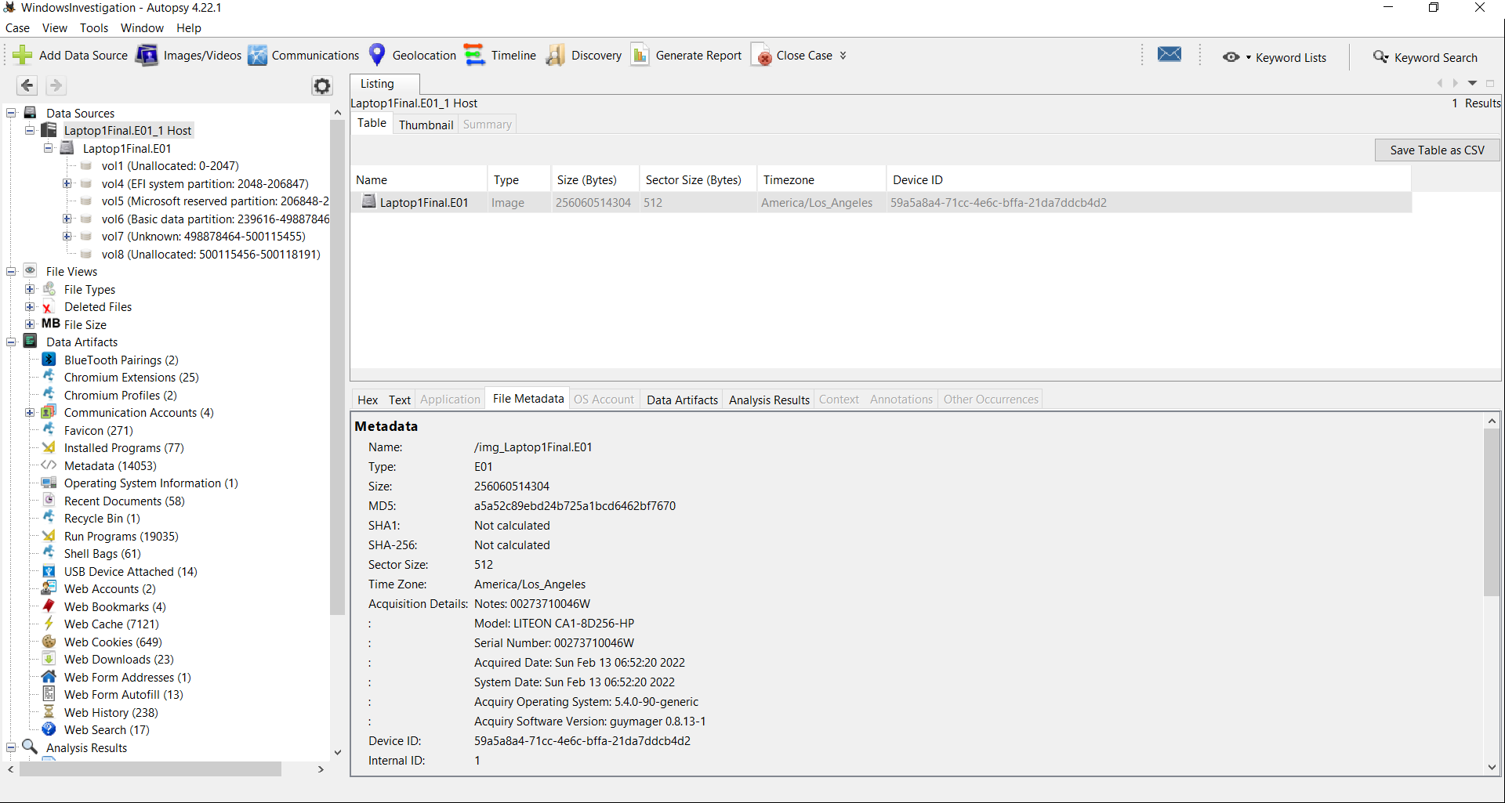
Figure 01: Calculated Hash of the FEF

- What is the hostname?
The hostname of the system is DESKTOP-SKPTDIO. This was determined by extracting the SYSTEM registry hive and analyzing it with RegRipper’s “compname” plugin.

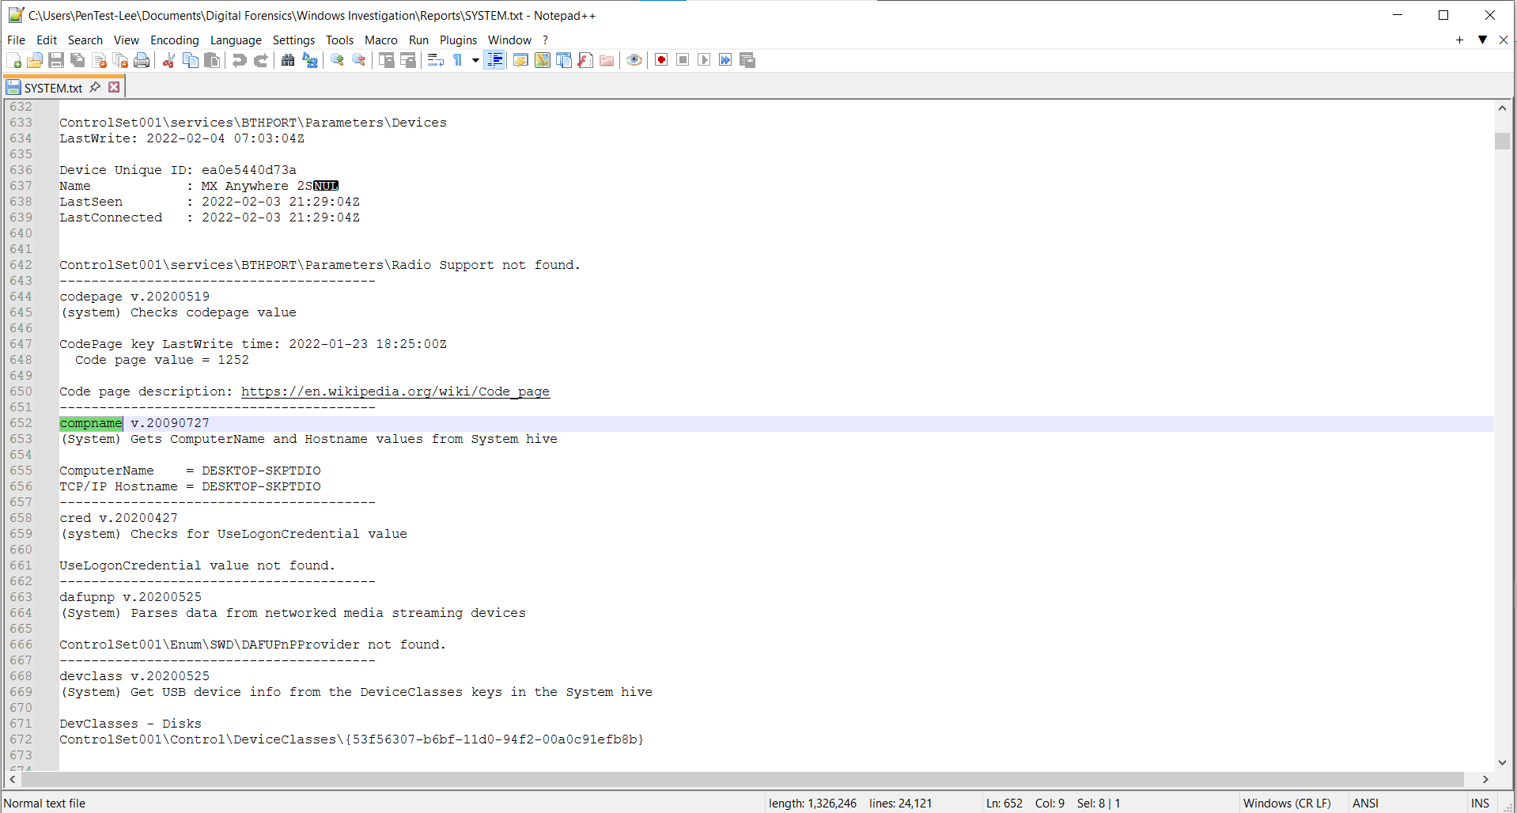
Figure 02: Hostname

- What version of Windows is currently installed? Was there another version previously installed? Provide evidence supporting your answer.
Current Version:
Windows 10 Home
Evidence:
Analysis of the SOFTWARE registry hive using RegRipper.
- ProductName: Windows 10 Home
- ReleaseID: 2009

Previous Version:
Yes, a previous version of Windows was installed on this system.
- Physical evidence: The “Windows.old” folder exists at “C:\Windows.old”, confirming an upgrade was performed and the previous installation was preserved
- Registry evidence: Analysis of the SOFTWARE hive extracted from “Windows.old\Windows\System32\Config” using RegRipper revealed the previous installation was:
- ProductName: Windows 10 Home
- ReleaseID: 2009
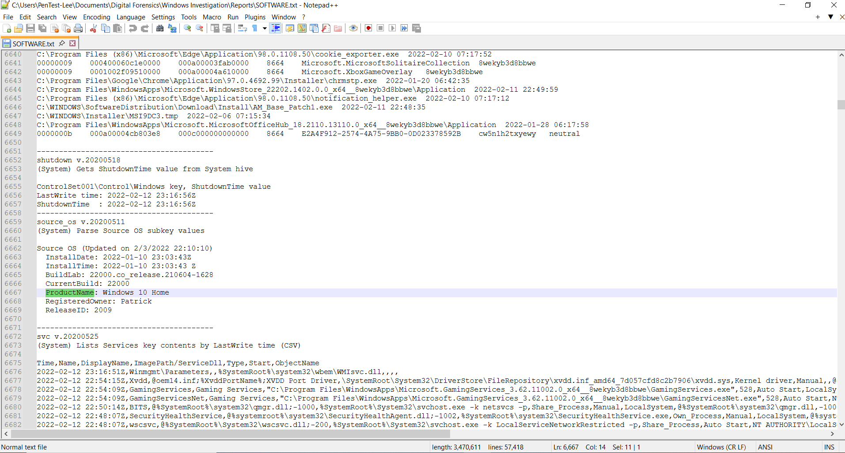
Figure 03: Version of the Window

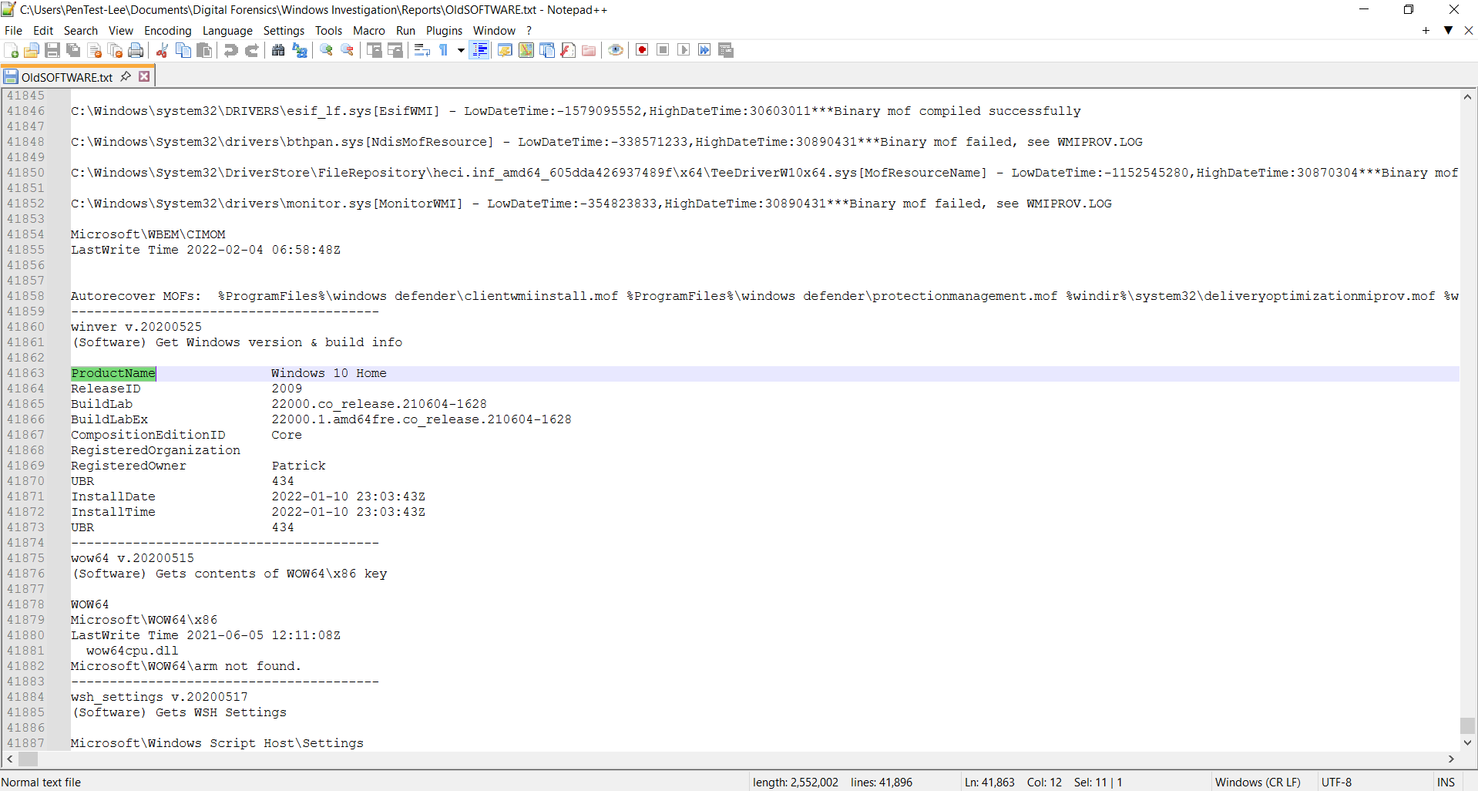
Figure 04: Previous Version of the Window

- What is the Time zone configured on the system? Provide evidence supporting your answer.
The system is configured with Eastern Standard Time. This was determined by extracting the SYSTEM registry hive and analyzing it with RegRipper’s timezone plugin, which returned “TimeZoneKeyName: Eastern Standard Time”.

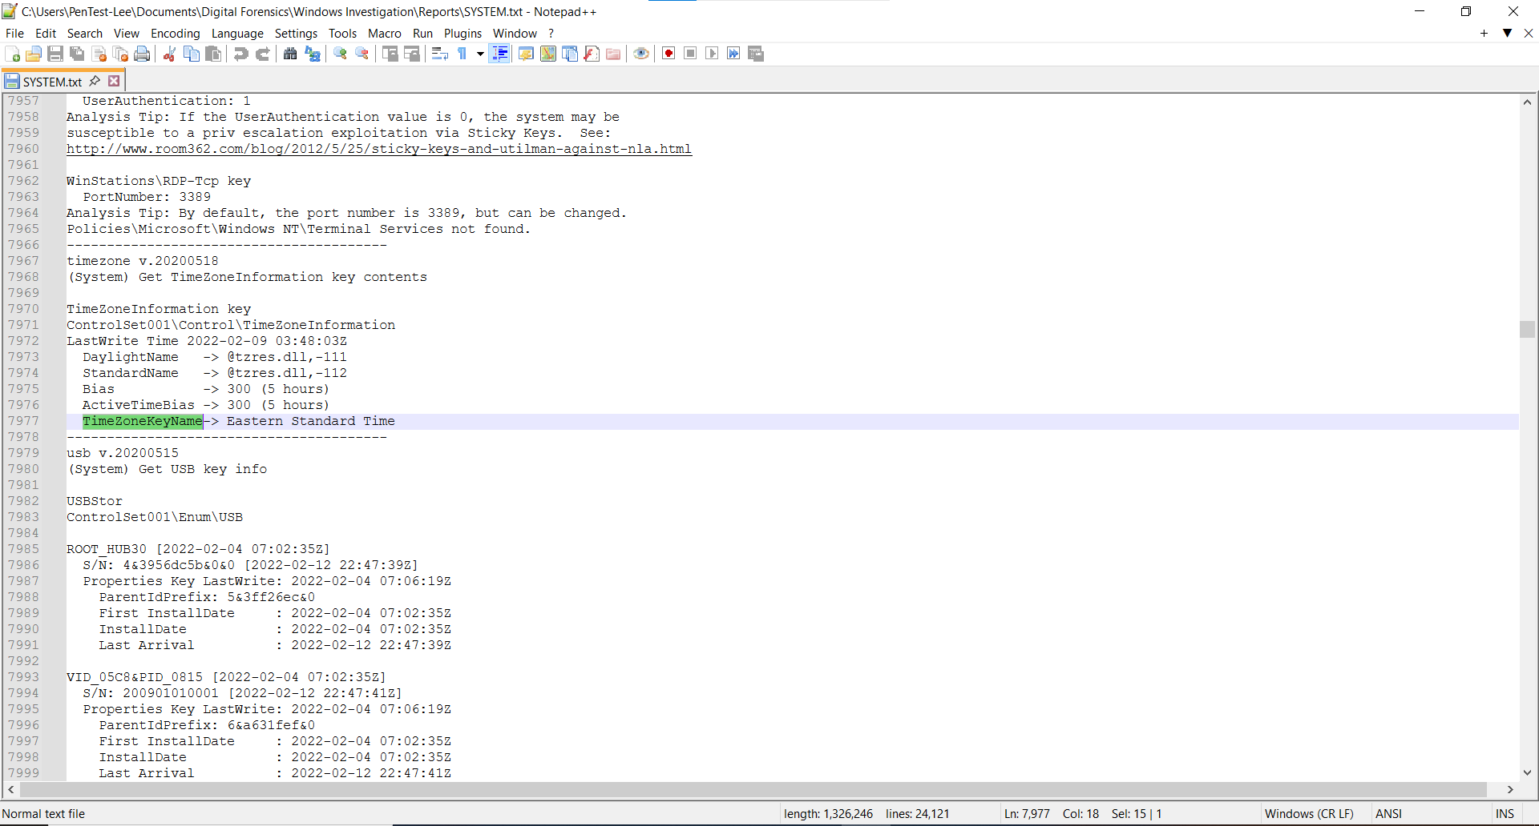
Figure 05: Time Zone configured in the system

- Was a mobile device connected to this Windows computer? Provide evidence supporting your answer.
Yes, a mobile device was connected to this Windows computer.

Evidence from two independent sources confirms an Apple iPhone was attached:

1. Registry Evidence (USB Enumeration):
Location: SYSTEM hive → Enum\USB
The presence of VID_8087&PID_0A2B with subkey "5&3ff26ec&0&7" indicates
a USB device was connected. While VID_8087 is Intel (USB controller),
the accompanying device information confirms an Apple device.

2. Data Artifacts → USB Device Attached:
Autopsy's automated USB device analysis explicitly identifies:
- Manufacturer: Apple Inc.
- Device Model: iPhone 5 / 5C / 5S / SE
- This artifact is generated by parsing USB device connection logs and registry entries

The combination of raw USB registry data and Autopsy's parsed USB artifacts
confirms that an Apple iPhone (5 series) was physically connected to this
system. The connection was detected and recorded by Windows, leaving
persistent forensic artifacts in both the registry and system logs.

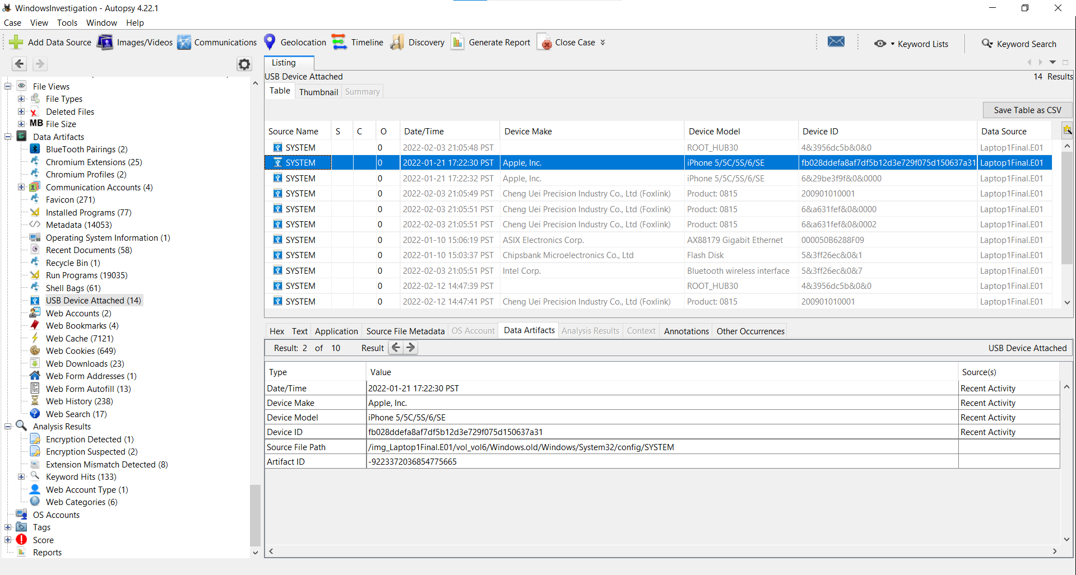
Figure 06: Mobile Device configure in the SYSTEM in Data Artifacts

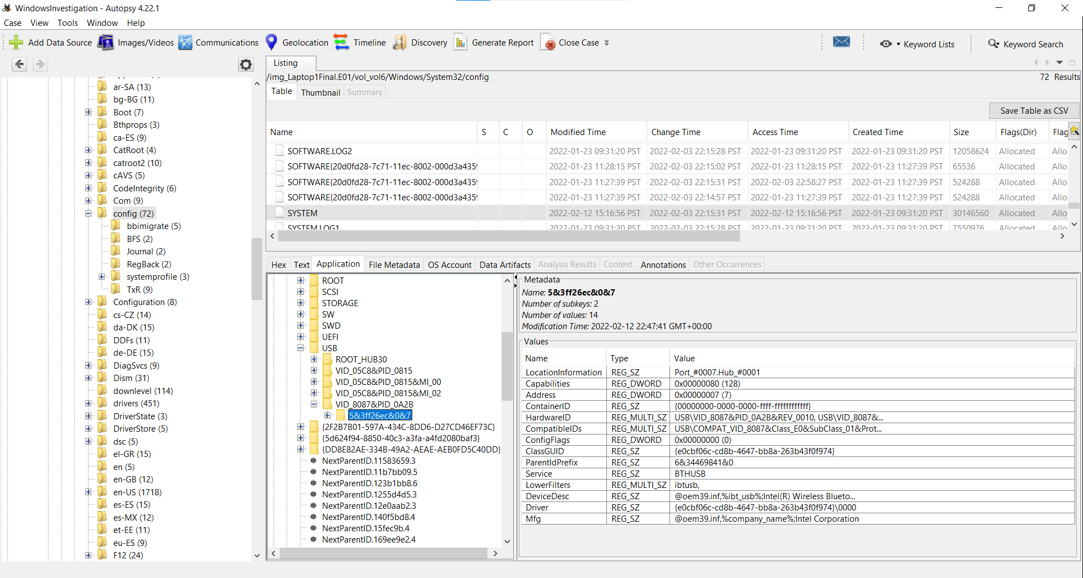
Figure 07: Mobile Device configure in the SYSTEM in ENUM file
- How many times did a user play a song by Rick Astley? Provide evidence supporting your answer.
The user played "Never Gonna Give You Up" by Rick Astley 9 times.

Evidence:
Using the search term "Rick Astley" in the extracted browser history text file,
9 separate entries were identified. Each entry corresponds to the YouTube video
"Rick Astley - Never Gonna Give You Up (Official Music Video)" with the unique
video ID "dQw4w9WgXcQ".

The 9 entries were found across the aggregated browser history, which includes
data from all browsers (Edge, Chrome, Firefox) and all user accounts on the system.
Each entry has a distinct timestamp, confirming 9 separate playback events rather
than a single visit.

Search Method:
- Opened extracted history text file in Notepad
- Used Ctrl+F to search for "Rick Astley"
- Counted 9 matches
- Verified each match contained the YouTube video ID "dQw4w9WgXcQ"

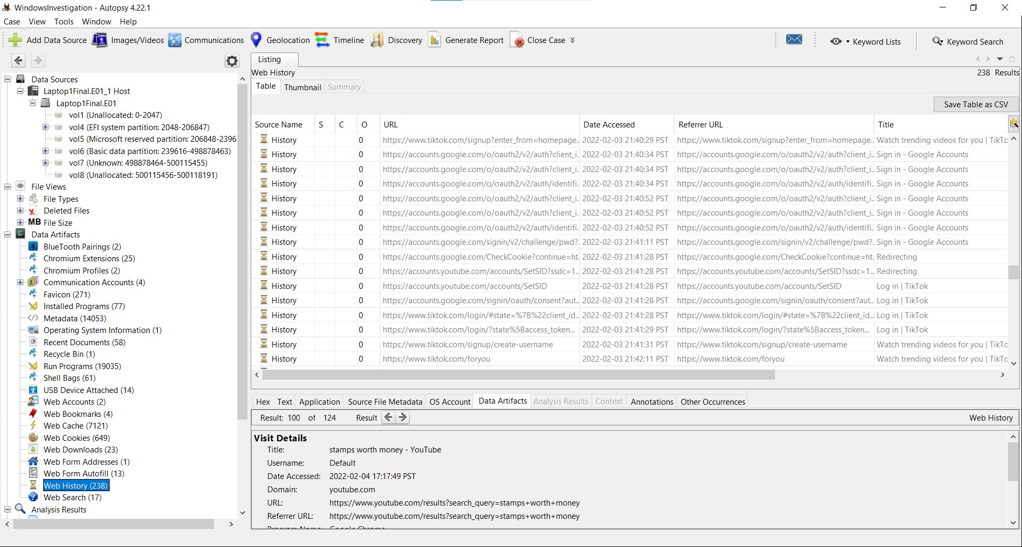
Figure 08: Web History to analyze User played song
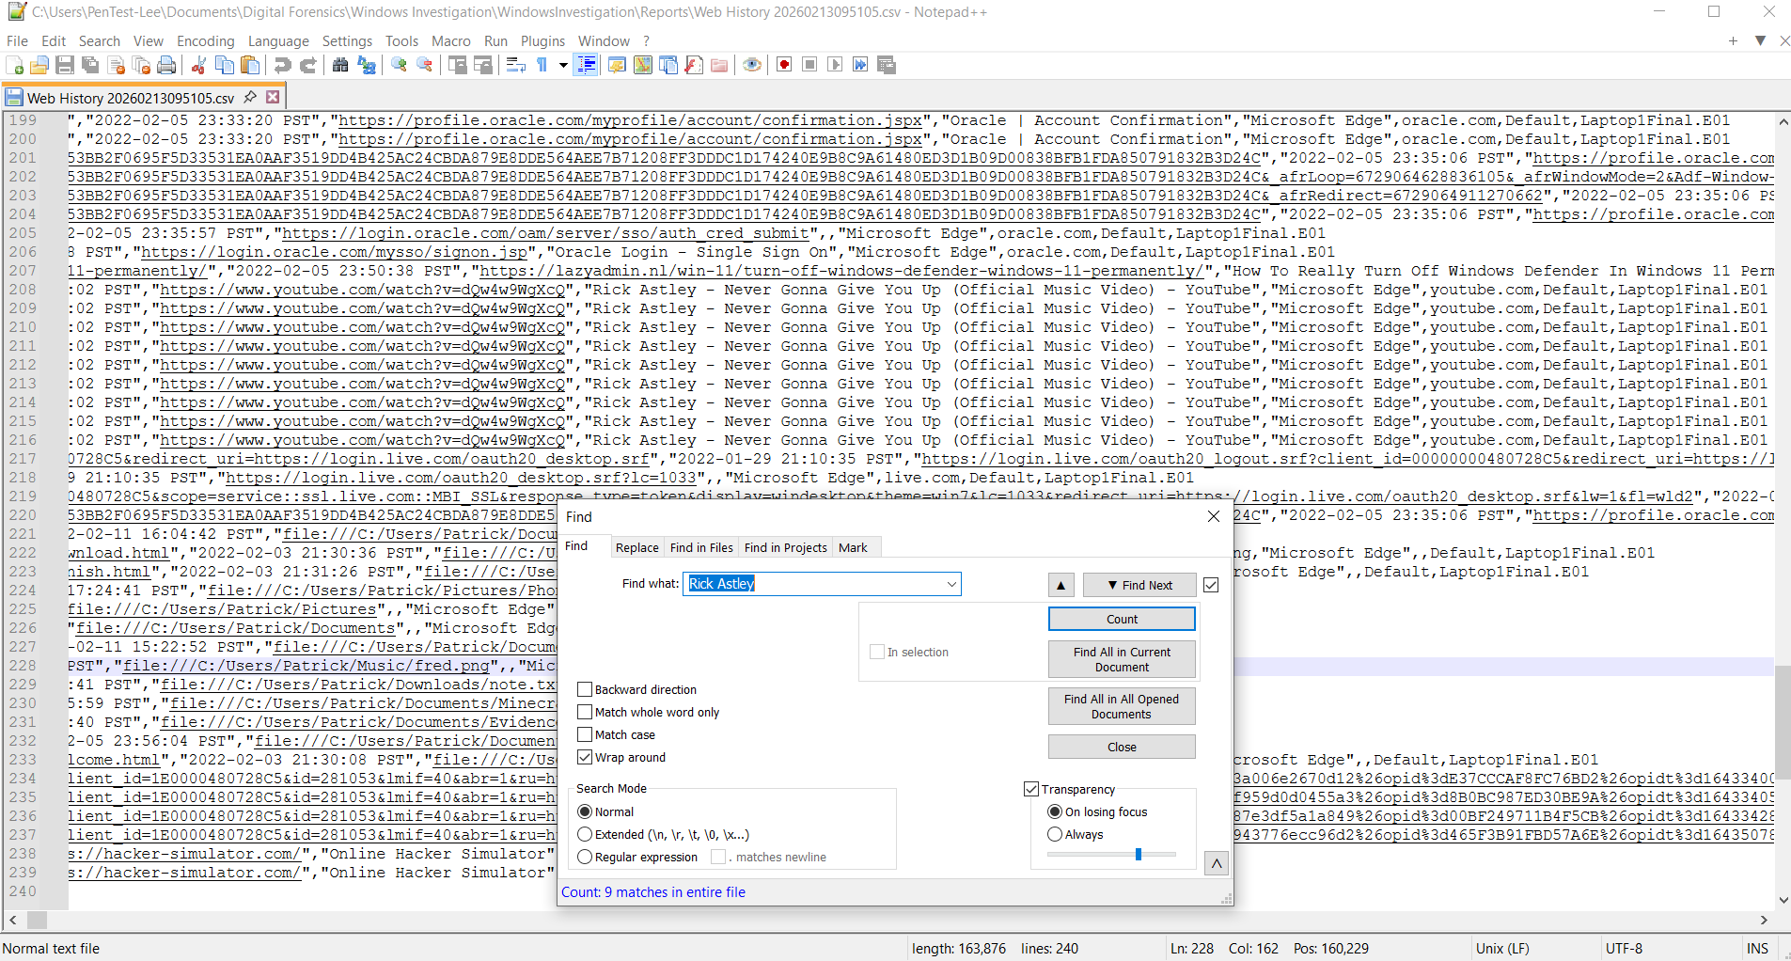
Figure 09: Data Analysis of played song

- Was there anything in the recycle bin that can be recovered? If so, what were the object’s real (original) names?
Yes, there was a recoverable item found in the Recycle Bin.

Analysis of the Recycle Bin:
Recycle Bin in Autopsy identified a deleted file with the system generated name $RZK8ELQ.exe. Examination of the corresponding metadata file $IZK8ELQ revealed the file’s original name and location.

Recovery details:
- Original file name: MinecraftInstaller.exe
- Original path: C:\Users\Patric\Downloads\MinecraftInstaller.exe
- Deletion time: 2022-02-03 20:51:05 PST
This confirms that a user deleted executable file was present in the Recycle Bin and that its original filename and path were successfully recovered through forensic analysis.
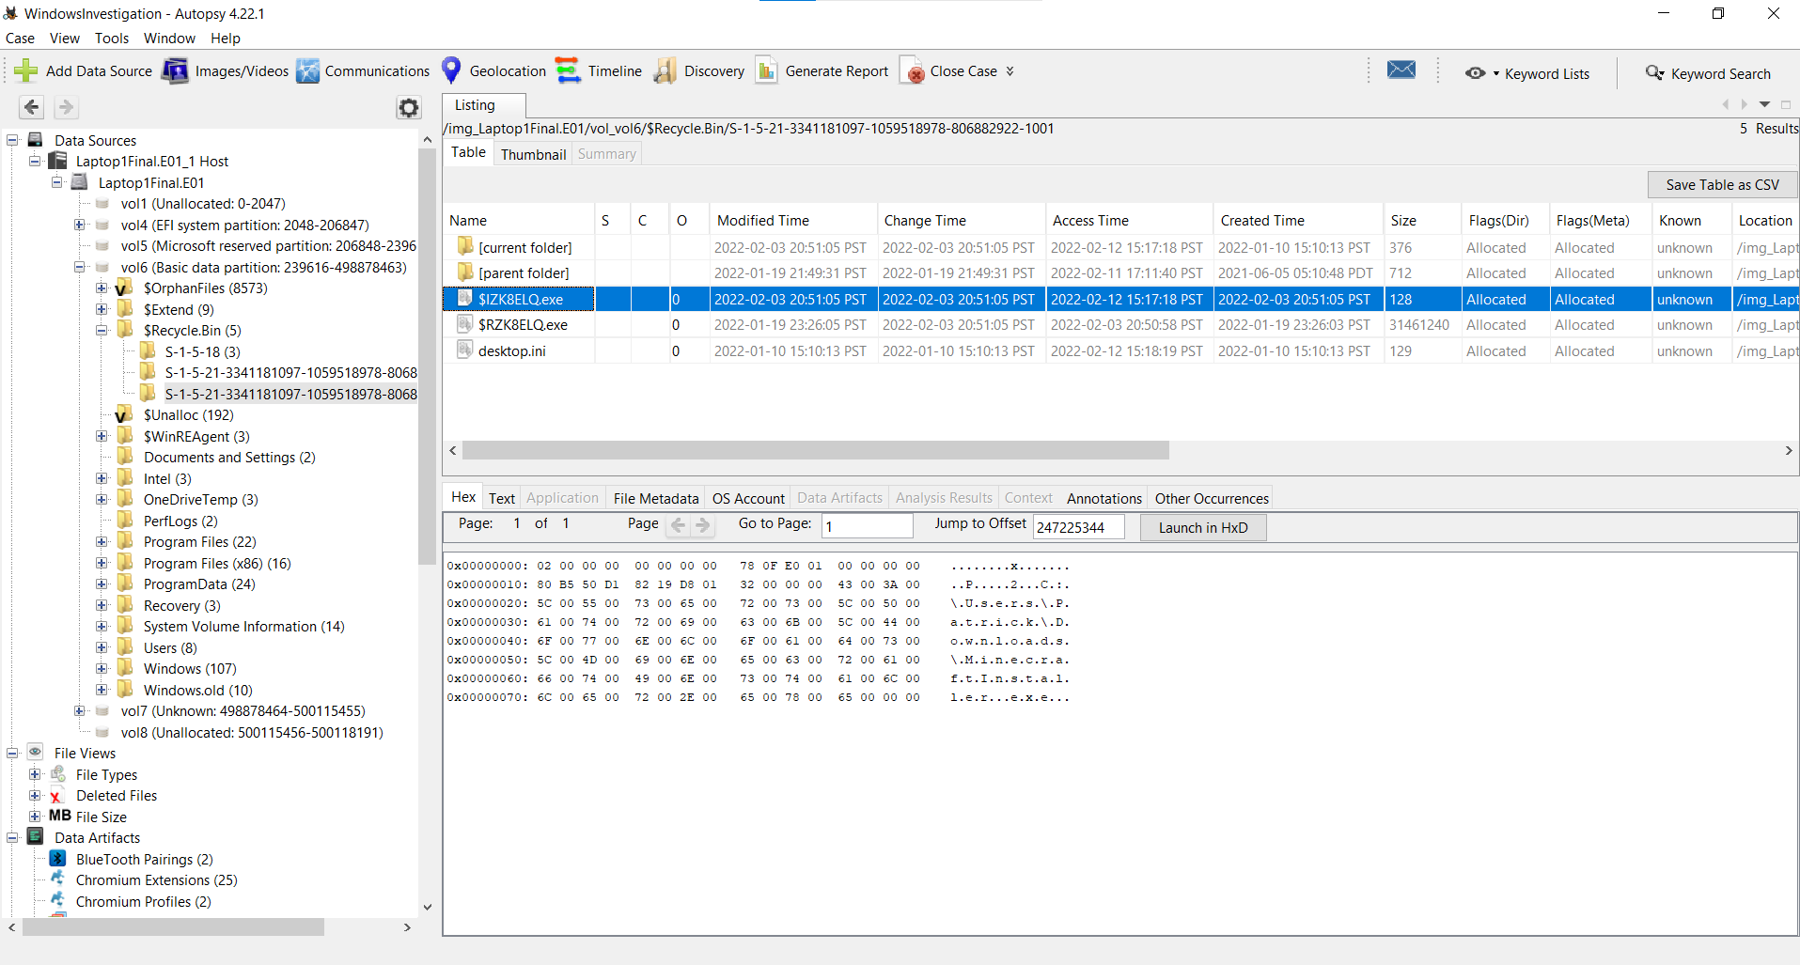
Figure 10: Recycle Bin File

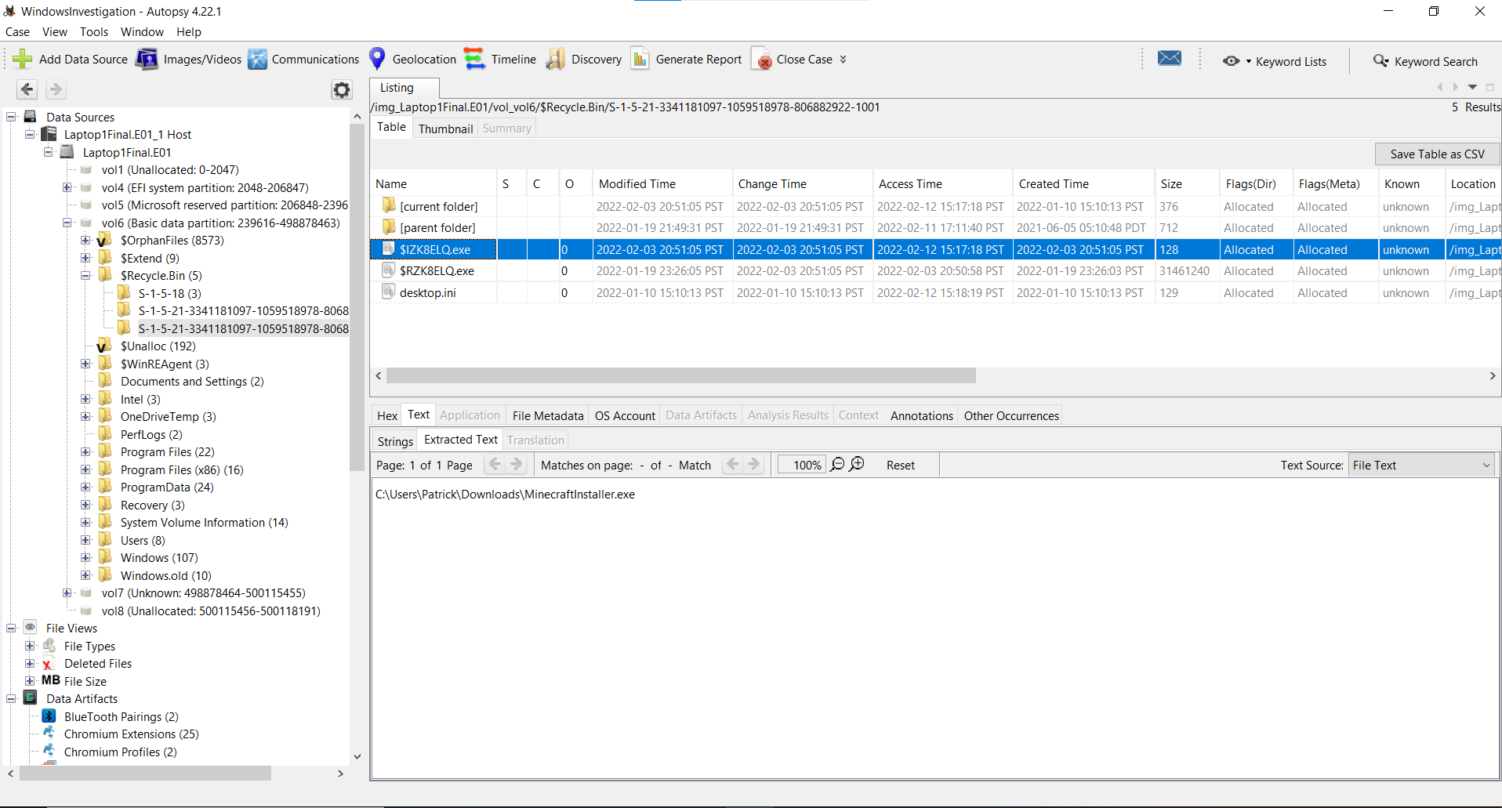
Figure 11: Recycle Bin File Path

- In review of the $MFT, what is the name AND the timestamps involved with the file that corresponds with $MFT entry: 241431
File Name:
Discord-1.0.9003-full.nupkg

Short (8.3) File Name:
DISCOR~1.NUP

Timestamps (all 2022-01-10):
- Created Time: 2022-01-10
- Modified Time: 2022-01-10
- Accessed Time: 2022-01-10
- Changed Time: 2022-01-10 (MFT Entry Modified)

Evidence Location:
MFT Entry 241431 at offset 247225344 in $MFT file (vol6 → $MFT)

Methodology:
The offset was calculated as: 241431 × 1024 = 247225344 bytes from start of $MFT.

The file name was identified in UTF-16 Little Endian format within the $FILE_NAME
attribute(s). The short name "DISCOR~1.NUP" and long name "Discord-1.0.9003-full.nupkg"
were both recovered.

All four timestamps show the same date (2022-01-10), indicating normal file creation
without timestamp manipulation. This date aligns with the initial system setup date
observed in user account creation timestamps.

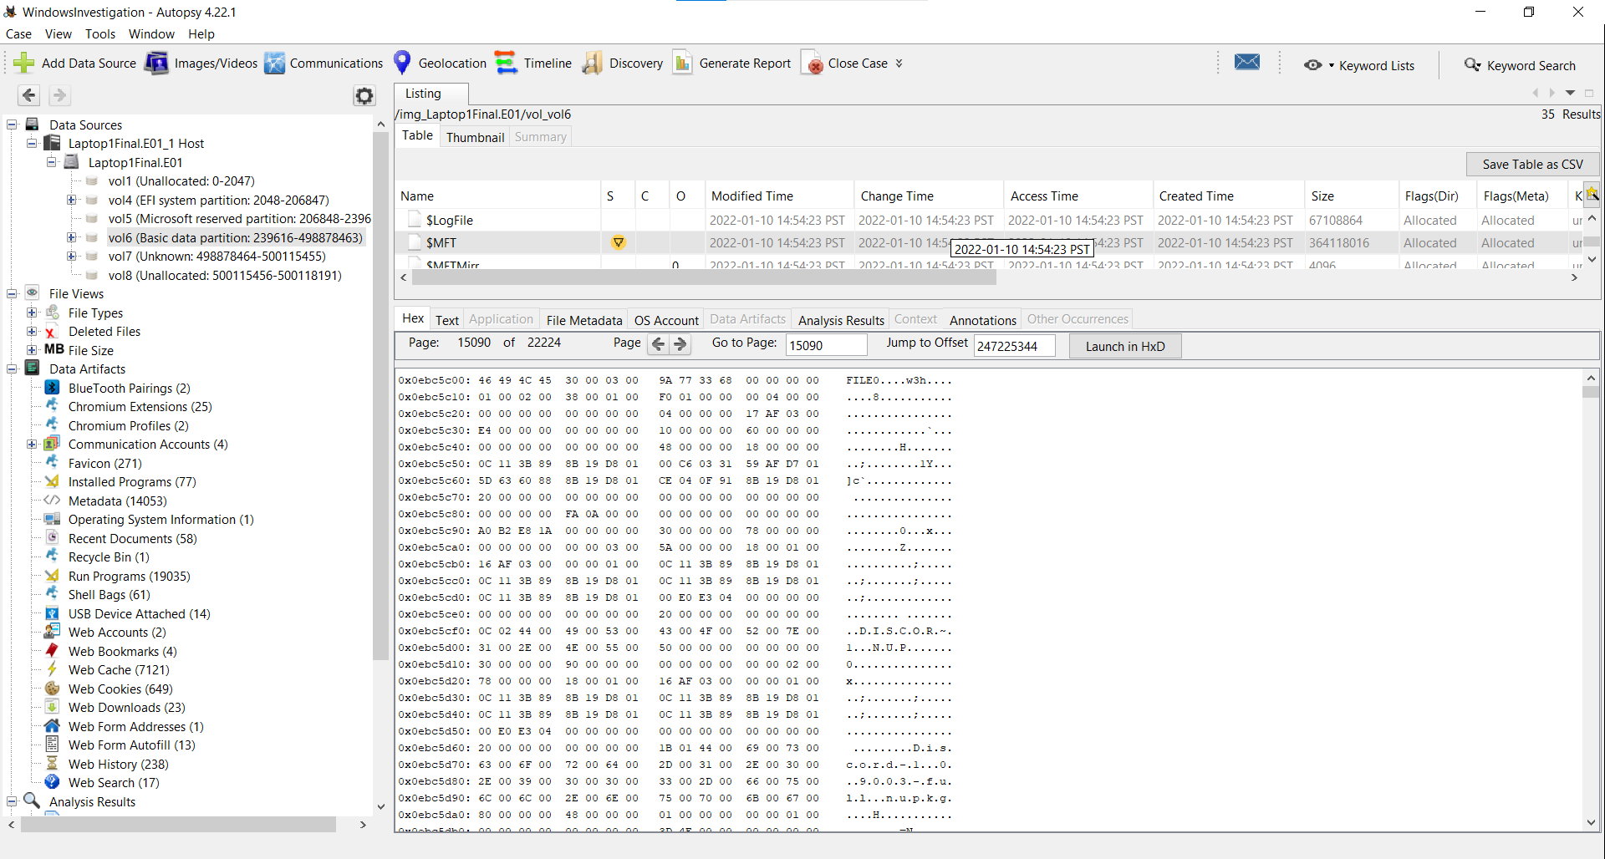
Figure 10: $MFT

- Unlike the previous Windows case*, this case has a Microsoft backed account information that still resides in SAM. Fill in the user chart below to list all accounts. You may add more rows, as necessary.
* In the previous case, the Selma account was no longer an existing account, so there was no entry in the SAM database.
SID | Display Name | Email (if applicable) | Creation Date
S-1-5-21-3341181097-1059518978-806882922-500 | Administrator | N/A | Fri Feb 4 07:02:36 2022 Z
S-1-5-21-3341181097-1059518978-806882922-501 | Guest | N/A | Fri Feb 4 07:02:36 2022 Z
S-1-5-21-3341181097-1059518978-806882922-503 | DefaultAccount | N/A | Fri Feb 4 07:02:36 2022 Z
S-1-5-21-3341181097-1059518978-806882922-504 | WDAGUtilityAccount | N/A | Fri Feb 4 07:02:36 2022 Z
S-1-5-21-3341181097-1059518978-806882922-1001 | Patrick | pbentley0107@gmail.com | Fri Feb 4 07:02:36 2022 Z
S-1-5-21-3341181097-1059518978-806882922-1002 | minecraftsteve | N/A | Sat Feb 12 01:29:43 2022 Z

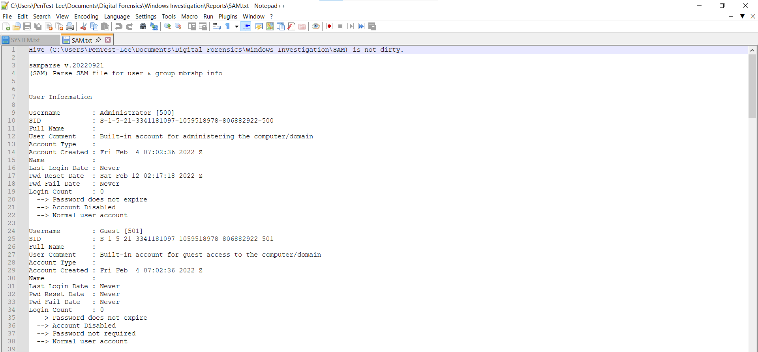
Figure 12: Admin and Guest Microsoft Backed Account

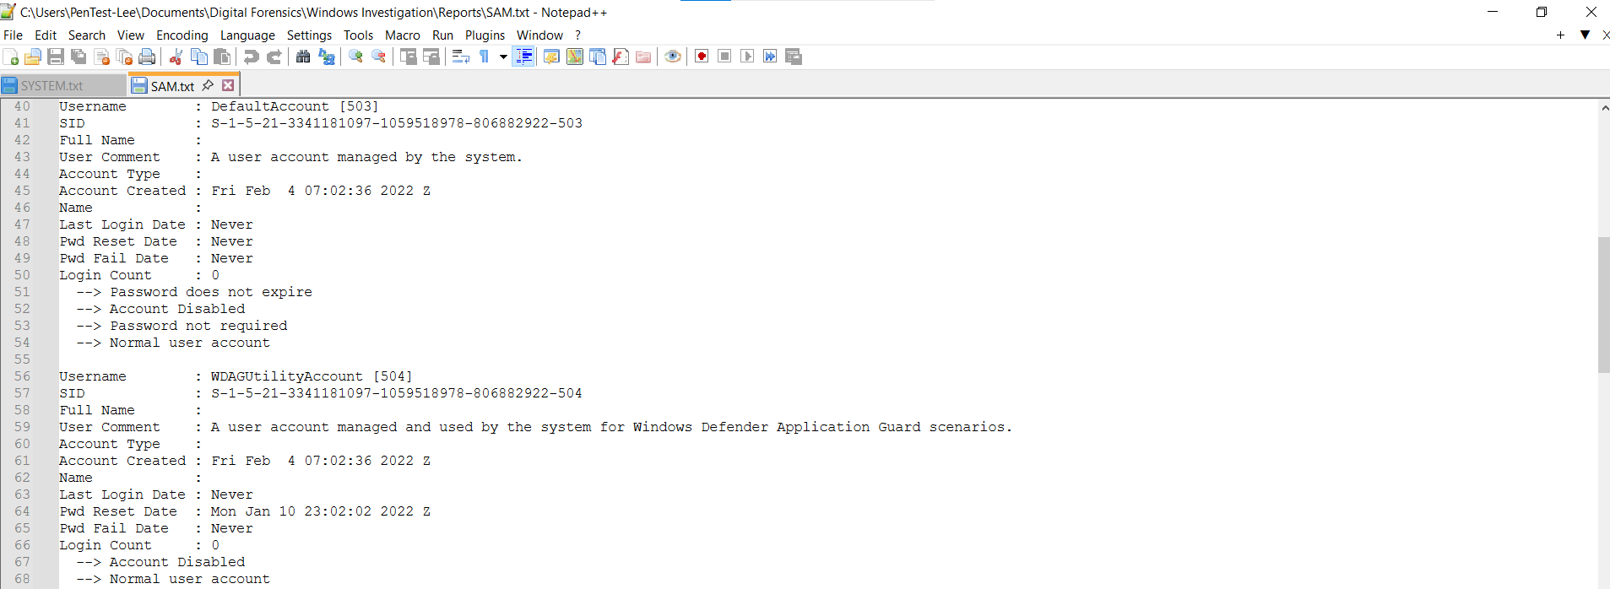
Figure 13: Default and WDAGUtility Microsoft Backed Account

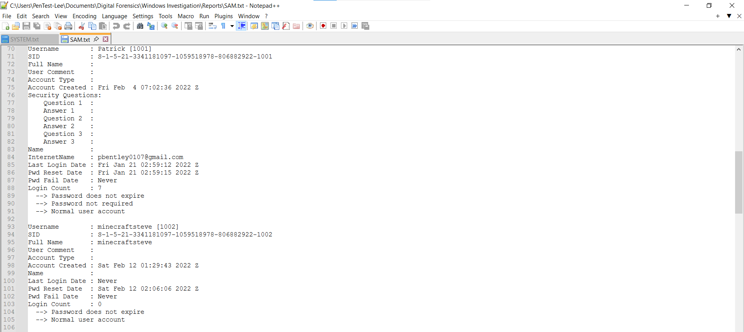
Figure 14: Patrick and minecraftsteve Microsoft Backed Account

10.) Fill in the program chart below. You may add more rows, as necessary.
Program Name | Install Date | Description
Java JDK 8u181 | 2022-02-06 | Java Development Kit
VLC Media Player | 2022-01-10 | Media playback application
Microsoft Office | 2022-01-10 | Productivity software suite
ZeroTier One | 2022-02-05 | Virtual networking software
Minecraft | 2022-02-03 | Game launcher for Minecraft
Discord | 2022-02-11 | Voice, video, and text communication app
Microsoft Edge | 2022-01-10 | Default Windows web browser
Windows Defender | 2022-01-10 | Built-in Microsoft antivirus
Google Chrome | 2022-01-20 | Web browser
Mozilla Firefox | 2022-01-10 | Alternative web browser
7-Zip | 2022-01-10 | File compression utility
Minecraft Launcher | 2022-02-11 | Game launcher for Minecraft

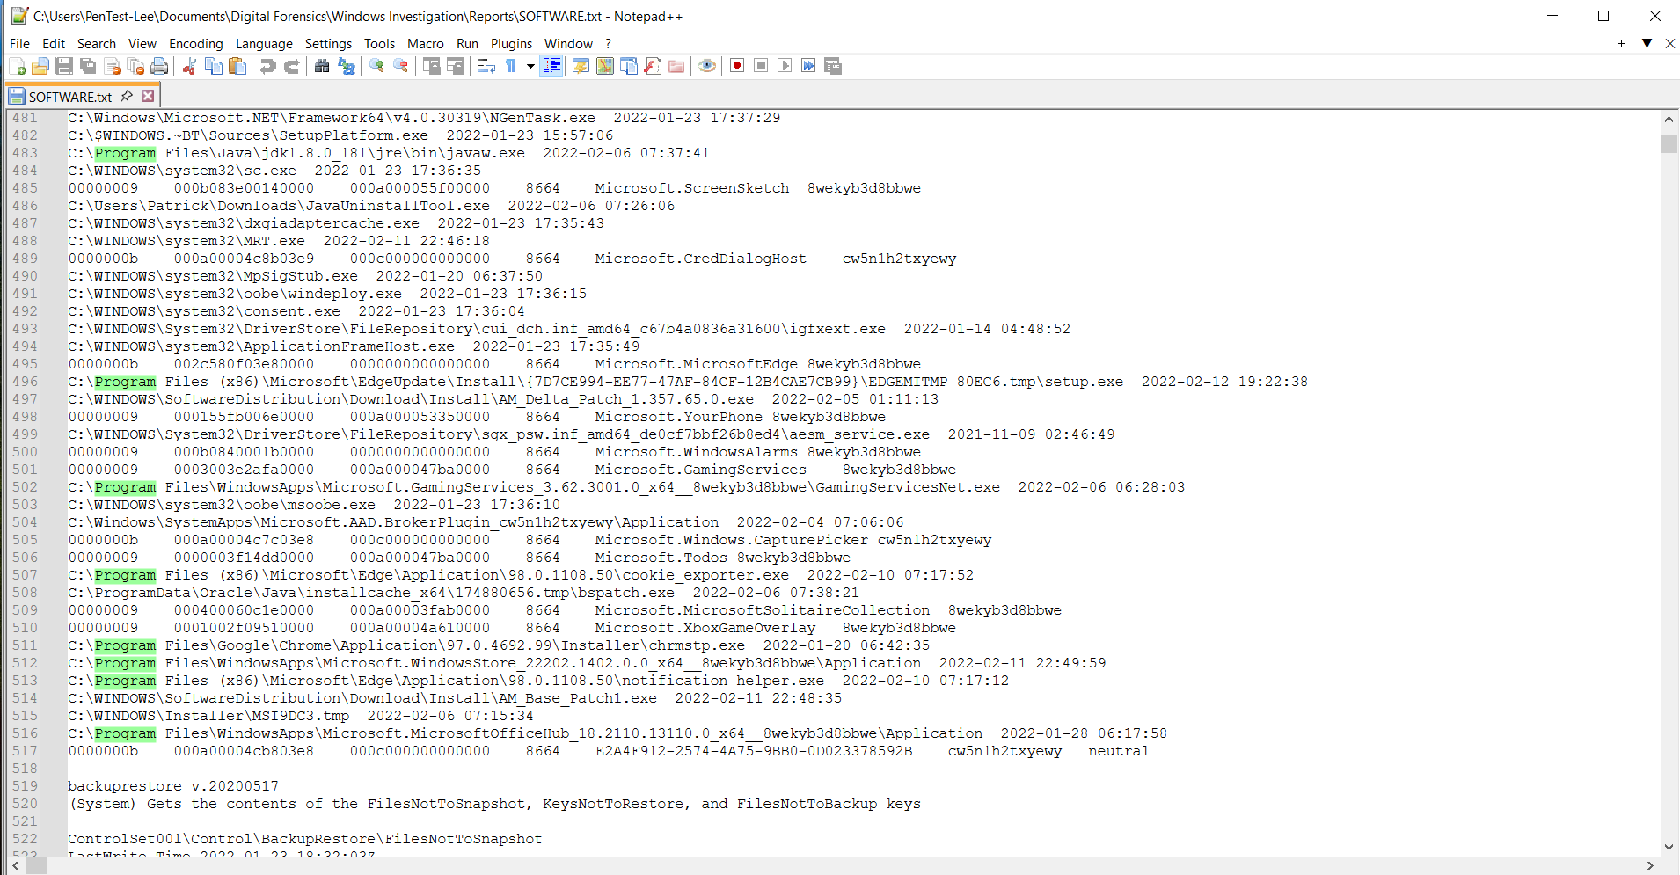
Figure 15: First Program Chart

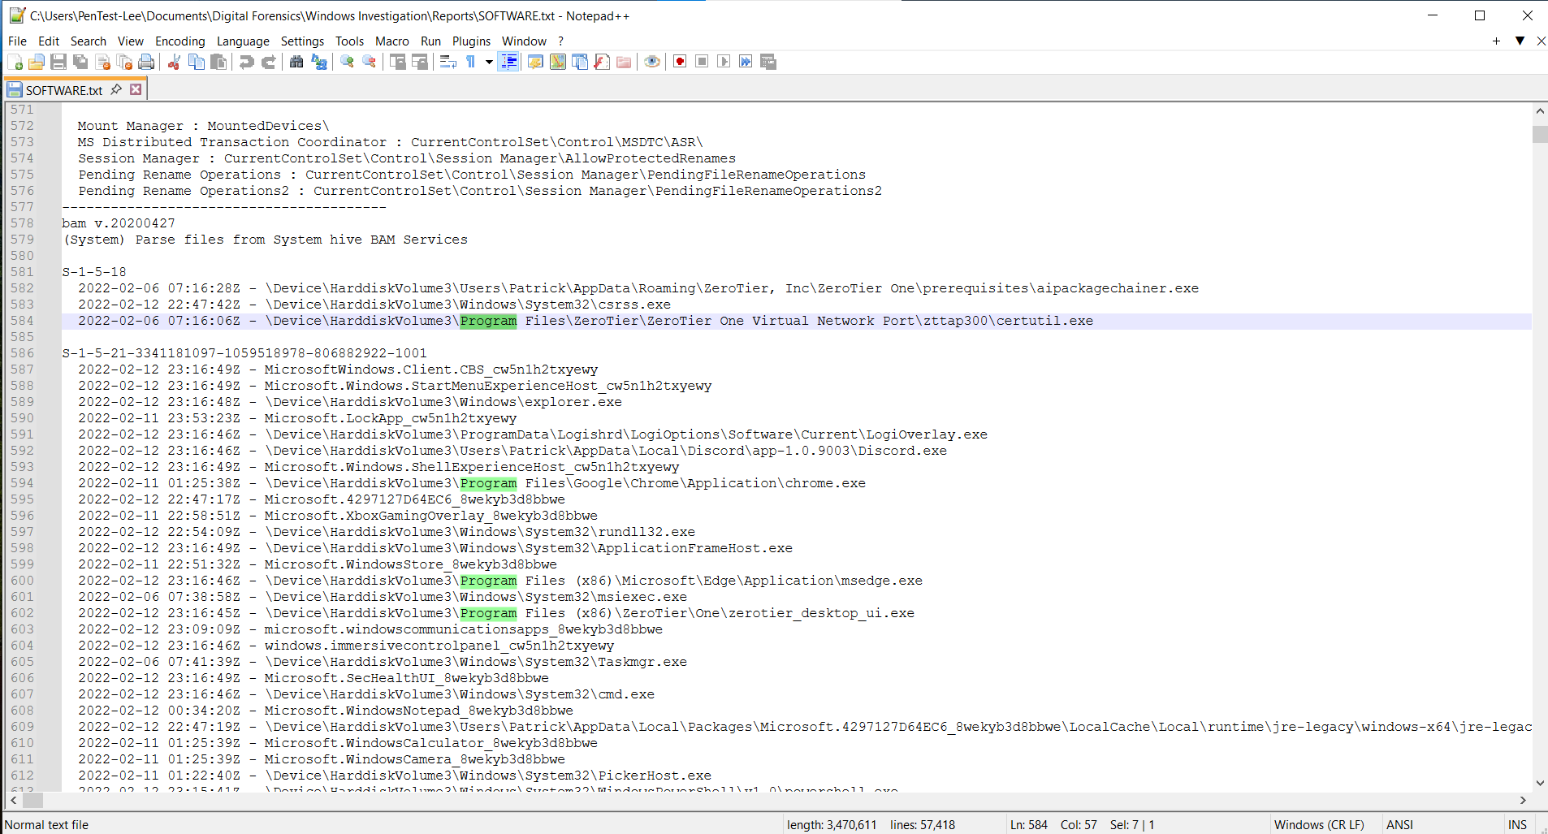
Figure 15: Second Program Chart

List “Fun Facts” that you found which were interesting/relevant, however not covered by these ten questions (There are plenty of interesting details) – Please go ahead and list them here.
Fun Facts (List at least three items):
1.) The Hibernation File – A Forgotten Forensic Treasure
The presence of hiberfil.sys on this system reveals the user preferred sleep/hibernate over full shutdown, prioritizing convenience over security. This file is essentially a memory dump containing whatever was in RAM at hibernation time potentially including open browser tabs (like the Rick Astley YouTube page), Discord chats, login sessions, and even password fragments. If the user hibernated while the video was playing, the hibernation file would contain browser memory pages with the YouTube video ID, providing corroborating evidence beyond web history. The related pagefile.sys can also contain fragments of program data never saved to regular files. Together, these represent a forensic treasure trove often overlooked by examiners.
2.) The Microsoft Account - Cloud Sync Enabled and Email Exposed
Patrick's account is a Microsoft-backed account linked to pbentley0107@gmail.com, enabling cloud sync of browser history, Wi-Fi passwords, and settings across devices. The email is stored in plain text in the SAM registry directly readable by forensic tools. Created the same day Windows was installed (February 4, 2022), this shows Patrick is comfortable with cloud services and unconcerned about privacy implications. Using a Gmail address with a Microsoft account reveals a hybrid online identity Google for email, Microsoft for OS. The email structure (p + bentley + 0107) strongly suggests the user's name is Patrick Bentley with a possible January 7 birthday, enabling OSINT searches across social media, gaming platforms, and public records.
3.) The PowerShell Scripts – Evidence of Automation and Learning
The user created two PowerShell scripts named goteem.ps1 and goteem2.ps1 in C:\Users\Patrick\Documents\Minecraft\, along with a batch file start.bat downloaded from Discord. The informal name "goteem" (slang for "get them") suggests a playful, gaming-oriented mindset, while the existence of two versions (goteem and goteem2) indicates trial and error the user was debugging and improving their work. Combined with visits to hacker-simulator.com, these artifacts reveal a user who wasn't just playing Minecraft but was actively learning automation, networking, and possibly exploring cybersecurity

